C:\STOCKLAYOUTS\CURRENT PROJECTS\FN99807-PL\FN99807-IMG03.emf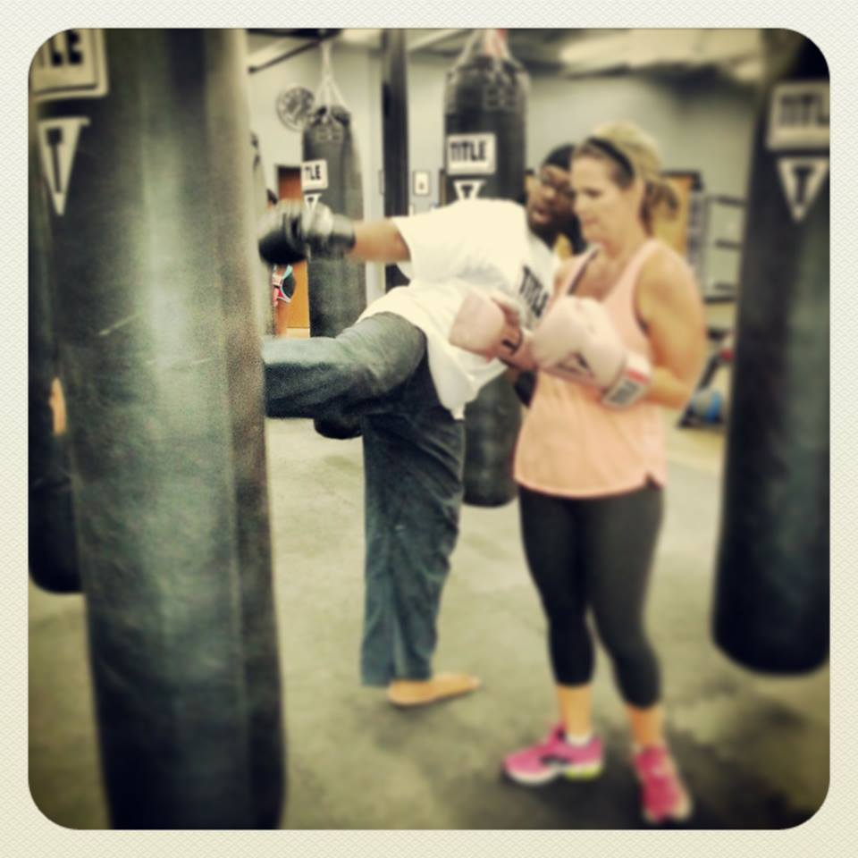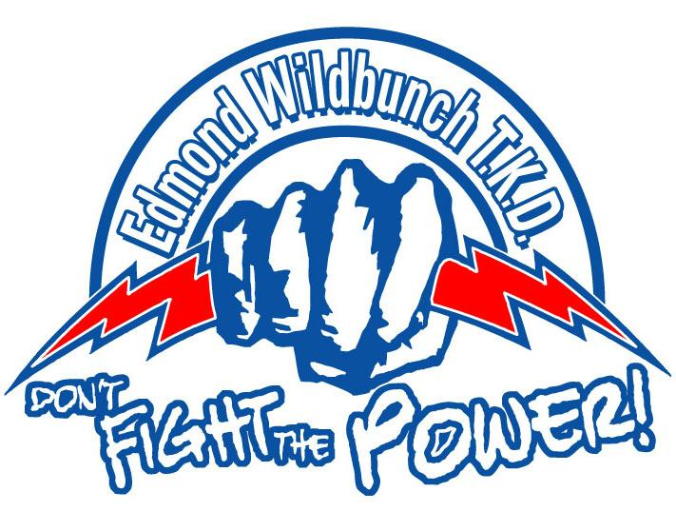

**“**

**”**

*Martial arts is a part of who I am, working out and training is part of my ethic. I feel that it’s something that every time you step onto the floor to train, you’re training your discipline; you’re training your will. A lot of people think it’s about the combative aspects of it and it’s not, it’s about you adhering to something that’s bigger than you and you working on bettering yourself!*

Your Partner For Success!

C:\STOCKLAYOUTS\CURRENT PROJECTS\FN99807-PL\FN99807-IMG05.emfMr. Bailey’s Bio:



Please call for further information

• Advice and Planning

• Motivational Inspiration

• Functional Fitness principles

• Kinesiology based principles

• Affordable Prices

• Group or 1-on-1 private sessions

• Reliable/Competent Instruction

Unified Martial Arts Training Center

803 S. Kelly Ave., Edmond, OK 73003

(405) 330-1996 or (405) 990-5958

Follow:

**Website**: [www.umatc.org](http://www.umatc.org)

**Twitter**: @UMATCEdmond

**YouTube**:<https://www.youtube.com/user/UnifiedMartialArts>

**Facebook**: Unified Martial Arts Training Center

**Elijah Bailey’s FFB (Functional Fitness Boot camp)**

**Instructor:**

Elijah Bailey

**Class Days/Times:**

Monday, Wednesday, Friday: 5:30-6:30 a.m.

Saturday: 7:30-9:30 a.m.

**Cost:** $50 per month

**Program Values:**

* Loyalty
* Duty
* Respect
* Honor
* Integrity
* Courage

addressing the needs of individual members and planting the seeds for a secure a successful future.

My name is Elijah Bailey, I am one of the lead instructors at Unified Martial Arts Training Center, Inc. I have been actively involved in martial arts since 1991 and I have been a Black Belt in Tae Kwon Do since 2002. I am currently a 4th Degree Black Belt through Unified Martial Arts Training Center and The Wild Bunch organization (one of the most prestigious traditional lineages of Korean Tae Kwon Do and Okinawan Goju Ryu within the state of Oklahoma for over 45 years). I have studied various forms of martial arts and fighting since I first began my training but before that I had never been a part of a martial arts family or brotherhood and that is what I like to infuse within my teaching.

I believe martial arts are an outlet for individual growth and development as well as a basis for families or communities to come together. I use martial arts as a term to not only refer to those styles or art forms that are popularized by social media(Tae Kwon Do, Karate, Judo, JuJutsu, etc.) but to codified systems and traditions of [combat](http://en.wikipedia.org/wiki/Combat) practices(such as boxing), which are practiced for a variety of reasons: [self-defense](http://en.wikipedia.org/wiki/Self-defense), [competition](http://en.wikipedia.org/wiki/Combat_sport), physical health and fitness, entertainment, as well as mental, physical, and spiritual development. I am currently a senior at the University of Central Oklahoma perusing my degree in Wellness and Exercise Management (Kinesiology) and also hold the title of Vice-President of the Oklahoma Karate Association.

I teach with the same passion which has driven and continues to drive me through my martial arts career. I believe martial arts are more than just systems in which you learn techniques or just fight; it is a lifestyle which prepares the mind and body for any physical and mental confrontation. I have always been passionate about martial arts and feel everybody has the right to know how to defend themselves if need be.

My philosophy is to produce the best quality of martial artist as well as people that I can with the knowledge and life lessons I have learned from martial arts. As with all things martial arts/boxing requires extreme dedication and effort, anything that is worthwhile in life is going to be hard so when you step into the gym believe in yourself and utilize the time you are here by giving your upmost. As an instructor I‘m not here to inspire you or motivate you for a day, I’m here to add value to your life. To help you change your life and reach your goals. I like to be in a continual state of becoming, with a goal in front and not behind and believe that every day we are alive we can do more, be more and achieve more than we did the day before. Always strive for the top in life because it’s the bottom that’s overcrowded.